**Scope Planning**

1. Defining the scope
2. Project requirements
3. Scope Inputs
4. Requirements traceability matrix
5. Work Breakdown Structure (WBS)
6. Scope statement

**Project Scope**

1. One of the main activities in the Project Planning phase is determining and documenting the project scope.
2. Project scope is the definition of all the work needed to successfully meet the project objectives.

**Deliverables**

Must be described in a sufficiently low level of details

**Scope**

1. Be as specific as you can
2. Where possible, the scope statements should include how the results will be measured so you and your sponsor will know with certainty whether that part of the scope has been achieved
3. Requirements should tie to things like the organization’s strategic plan and business objectives
4. Mention things that are explicitly NOT included: is this limited to certain locations? If in an international context, is it in only one language?

**Scope**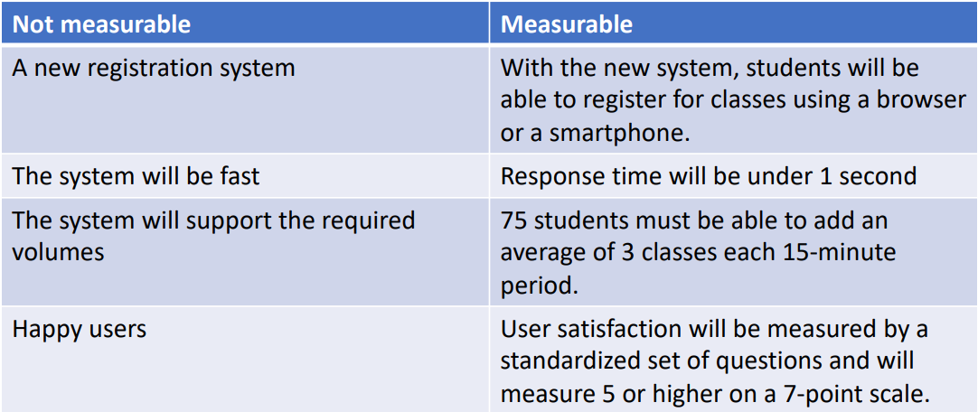

**Types of requirements**

1. Functional
2. Non-functional
   1. Performance
   2. Development
3. Technical
4. Business
5. User
6. Regulatory

**Software requirements fundamentals**

1. Unique challenges
2. Must be verifiable

**Measuring requirements**

Each type of requirement may require a different type of measure: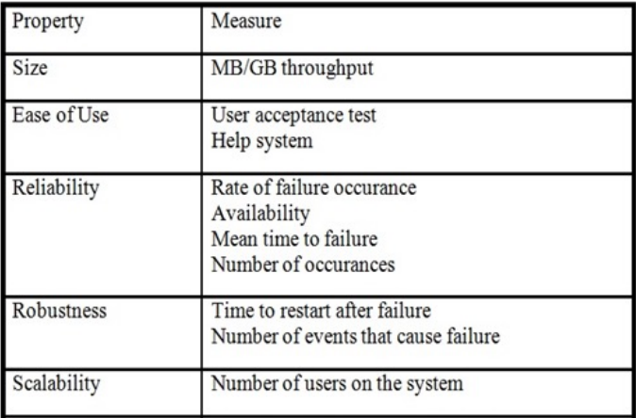

**Scope inputs-techniques**

1. Interviews
2. Focus groups
3. Facilitated groups– JAD, QFD
4. Group creativity techniques such as brainstorming
5. Prototyping
6. Observation
7. Questionnaires and surveys

**Scope Inputs-sources**

1. Project sponsor
2. Management
3. Strategic Plan
4. Users
5. Customers
6. Competitors
7. Suppliers
8. Regulations
9. and others

**Requirements Traceability Matrix**

1. Links requirements to their origin
2. Traces them throughout the project process
3. May link requirements to business needs, opportunities, goals, and objectives
4. Project objectives
5. Project scope/WBS deliverables
6. Product design
7. Product development
8. Test strategy and test scenarios
9. or may link High-level requirements to more detailed requirements.

**Requirements Traceability Matrix fields**

1. Unique identifier
2. Requirement statement
3. Source
4. Design specification reference
5. Test specification
6. Test case numbers
7. Remarks
8. and more depending on the particular situation

**WBS Creation**

1. List all the project outputs (deliverables and other direct results)
2. Identify all the activities required to deliver the outputs
3. Subdivide the activities into sub-activities and tasks
4. Identify the deliverable and milestone(s) of each task

**Creating the WBS**

1. A list of all activities required to create all the deliverables in the scope
2. Activities may be broken down into smaller tasks, in a hierarchical pattern
3. Do not focus on sequence or dependencies at this point

**Creating the WBS**

1. Follow a numbering plan
2. Can also be shown in outline format
3. May be very complex for a large project

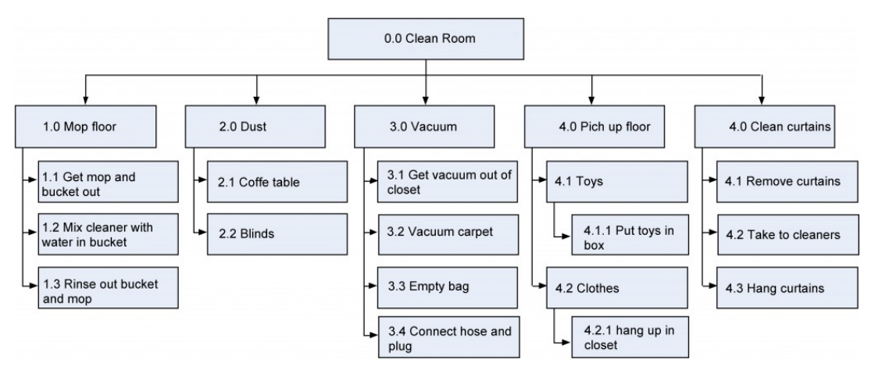

**WBS Creation**

Remember the 100% Rule:

The combination of the boxes on each level represents 100% of the parent box.

**WBS Creation**

1. At the lowest level, the WBS consists of Work Packages
2. It is important that each work package is clearly defined and can be easily assigned
3. The work package level is where time estimates, cost estimates and resource estimates are determined.

**Scope Statement**

1. Purpose:
   1. Project deliverables
   2. Major objectives
   3. Measurable success criteria
2. Create and use a template suitable to your organization

**Scope Statement Typical Contents**

1. Project Name
2. Project charter
3. Owner, sponsor, project manager, stakeholders
4. Problem statement
5. Project Goals and Objectives
6. Project Requirements
7. Project Deliverables
8. Exclusions
9. Milestones
10. Cost estimates

**Summary**

1. Scope planning is an essential activity during the planning phase of the project
2. Provide relevant details and measurable deliverables in your scope
3. Use a Requirement Traceability Matrix to relate the deliverables to their sources and keep track of the status
4. Create a WBS as a hierarchy
5. Remember the 100% rule
6. The scope statement includes:
   1. Project Name
   2. Project charter
   3. Owner, sponsor, project manager, stakeholders
   4. Problem statement
   5. Project Goals and Objectives
   6. Project Requirements
   7. Project Deliverables
   8. Exclusions
   9. Milestones
   10. Cost estimates